https://doi.org/10.47093/2218-7332.2022.338.06.S

Дополнительные материалы / Supplementary Materials

A male white mouse. The abdomen was shaved and anaesthesia was administered. After anaesthesia, a UCNP mixture preparation (150 µl) was injected into the retroorbital sinus. The image was taken 10 min after the drug administration Fig. S1.
The mouse was removed from the experiment, the liver, spleen, and lungs were extirpated and divided into two parts — one set immersed in formalin, the other frozen Fig. S1.

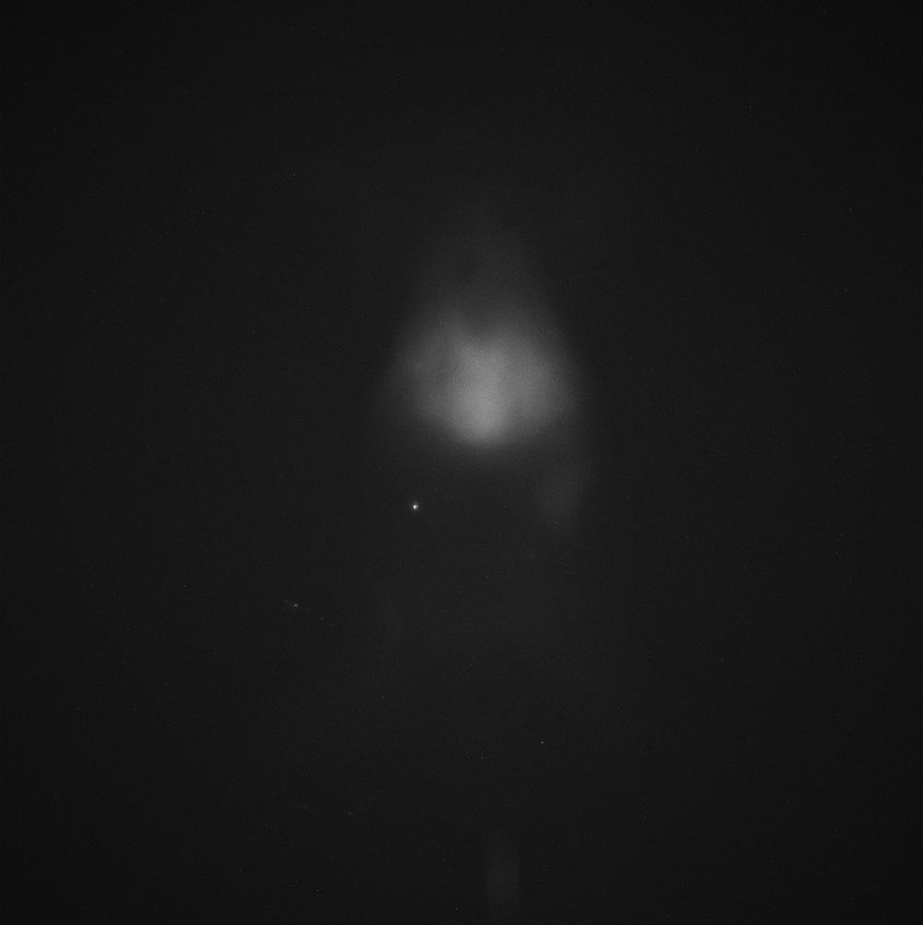 | 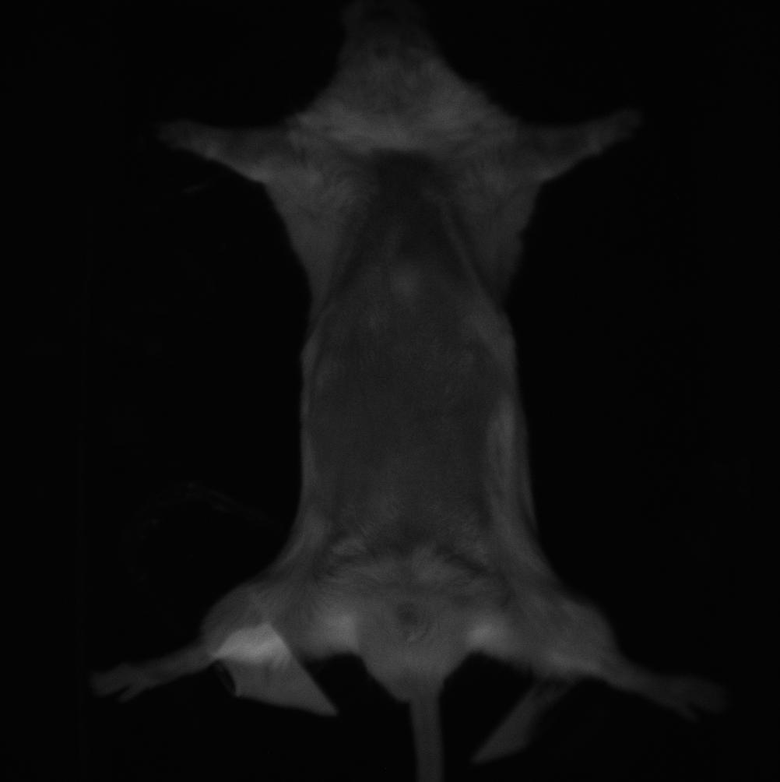
FIG. S1. M1-mix mouse.
The image was obtained 10 minutes after injection. Left panel — epiluminescence image, right panel — light-field image.
РИС. S1. Мышь M1-mix.
Изображение получено через 10 минут после инъекции. Слева — эпилюминесцентное изображение, справа — изображение в светлом поле.

